表过滤器管理工程

设计要点
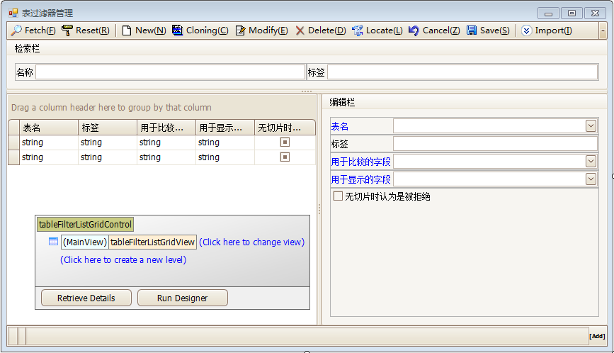
需关注以下几点：
- “表名”输入框的下拉内容，需罗列出数据字典中所有的表信息；
- 与表字段相关（“用于比较的字段”、“用于显示的字段”）的输入框下拉内容，需与当前“表名”关联的数据字典表字段清单保持一致；
- 当修改“表名”后，需将“标签”输入框内容替换为当前“表名”下的数据字典表信息Description值；

设计方法

技术准备
本业务场景，需要和数据库的数据字典打交道。鉴于各款数据库在数据字典的设计上差异巨大，Phenixヾ在Phenix.Core程序集中（Phenix.Core.Data.Schema命名空间）专门提供了面向对象、可导航的数据字典检索类：Database（数据库）、Table（表）、View（视图）、Column（字段）、Index（索引）、ForeignKey（外键），除了自身功能实现需要外，也可满足本工程的功能实现需要。

级联选择清单

第一级选择清单
第一级选择清单是数据字典的表信息清单。
为了拿到数据字典的表信息清单，必须从Phenix.Core.Data.Schema.Database入口，通过调用它的TableList属性获取：

private Phenix.Core.Data.Schema.Database Database
{
get { return Phenix.Core.Data.Schema.Database.Fetch(null); }
}

/// <summary>
/// 数据库表清单
/// </summary>
public ReadOnlyCollection<Phenix.Core.Data.Schema.Table> DatabaseTables
{
get { return Database.TableList; }
}

这些代码应该放到TableFilter类中，以配合界面的逻辑设计，尽可能减少界面的代码编写量（DatabaseTables属性可以被直接绑定，在界面上自动展现Database.TableList的数据）。
编译好Phenix.Security.Business工程后，我们在界面上添加databaseTablesBindingSource组件，然后手工设置成：
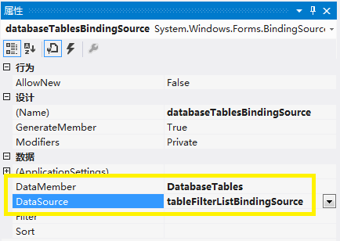
接下来，“表名”下拉框的数据源等属性设置，也需手工操作：
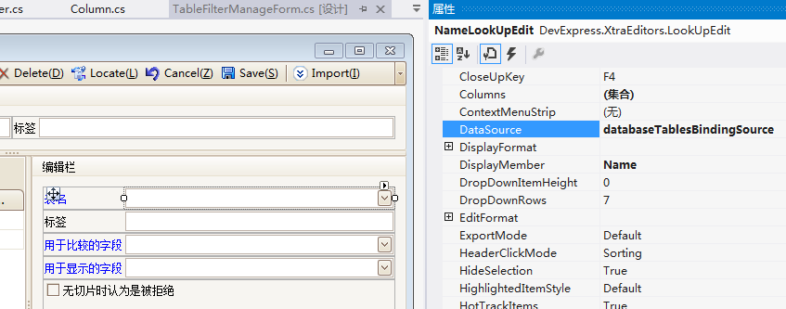
具体手工操作了哪些属性，可从TableFilterManageForm.Designer代码中看到，摘录如下：

//
// NameLookUpEdit
//
this.NameLookUpEdit.DataBindings.Add(new System.Windows.Forms.Binding("EditValue", this.tableFilterListBindingSource, "Name", true));
this.barManager.SetFriendlyCaption(this.NameLookUpEdit, this.ItemForName);
this.NameLookUpEdit.Location = new System.Drawing.Point(99, 12);
this.NameLookUpEdit.MenuManager = this.barManager;
this.NameLookUpEdit.Name = "NameLookUpEdit";
this.NameLookUpEdit.Properties.Buttons.AddRange(new DevExpress.XtraEditors.Controls.EditorButton[] {
new DevExpress.XtraEditors.Controls.EditorButton(DevExpress.XtraEditors.Controls.ButtonPredefines.Combo)});
this.NameLookUpEdit.Properties.Columns.AddRange(new DevExpress.XtraEditors.Controls.LookUpColumnInfo[] {
new DevExpress.XtraEditors.Controls.LookUpColumnInfo("Name", "Name", 40, DevExpress.Utils.FormatType.None, "", true, DevExpress.Utils.HorzAlignment.Near),
new DevExpress.XtraEditors.Controls.LookUpColumnInfo("Description", "Description", 70, DevExpress.Utils.FormatType.None, "", true, DevExpress.Utils.HorzAlignment.Near)});
this.NameLookUpEdit.Properties.DataSource = this.databaseTablesBindingSource;
this.NameLookUpEdit.Properties.DisplayMember = "Name";
this.NameLookUpEdit.Properties.ImmediatePopup = true;
this.NameLookUpEdit.Properties.MaxLength = 30;
this.NameLookUpEdit.Properties.NullText = "";
this.NameLookUpEdit.Properties.TextEditStyle = DevExpress.XtraEditors.Controls.TextEditStyles.Standard;
this.NameLookUpEdit.Properties.ValueMember = "Name";
this.NameLookUpEdit.Size = new System.Drawing.Size(289, 21);
this.NameLookUpEdit.StyleController = this.tableFilterListDataLayoutControl;
this.NameLookUpEdit.TabIndex = 5;

可以调试下，看看效果：
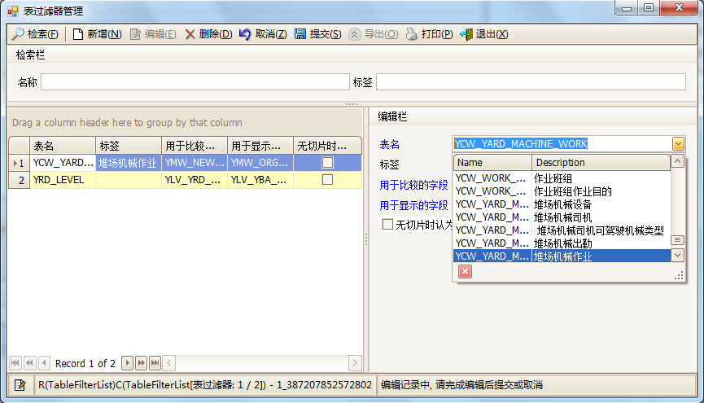

第二级选择清单
第二级选择清单内容，是根据第一级被选择项筛选出来的。所以，这个清单对象的定义应该作为属性放在TableFilter类中。这不仅仅是为了方便界面组件的绑定，也是符合领域建模的惯例（界面操作仅仅是处理对象的一种方式，即使人工编写代码来处理这个对象，它对外提供操作的接口设计，也应该尽可能迎合人类思维逻辑的习性（概念、判断、推理等思维形式和比较、分析、综合、抽象、概括等方法），允许低成本地掌握对象的使用方法）：

public Phenix.Core.Data.Schema.Table Table
{
get { return !String.IsNullOrEmpty(Name) ? Database.FindTable(Name) : null; }
}

/// <summary>
/// 表字段清单
/// </summary>
public ReadOnlyCollection<Phenix.Core.Data.Schema.Column> TableColumns
{
get { return Table != null ? Table.ColumnList : new ReadOnlyCollection< Phenix.Core.Data.Schema.Column>(new List< Phenix.Core.Data.Schema.Column>()); }
}

本业务场景，第一级的被选择项是Table属性（通过调用Database.FindTable()函数获取到，实际读写、持久化的是Name属性，也就是表名）。这样，第二级选择清单就是Table对象的ColumnList属性值，将它作为TableFilter类的属性TableColumns返回值提供给对象操作者。对于界面设计来说，就是将TableColumns属性绑定到tableColumnsBindingSource：
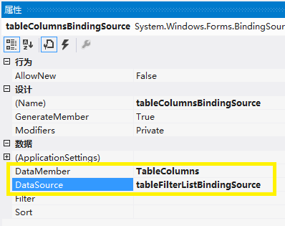
然后，就可以为那两个下拉框设置好相关的属性，完成后可在TableFilterManageForm.Designer代码中看到，摘录如下：

//
// CompareColumnNameLookUpEdit
//
this.CompareColumnNameLookUpEdit.DataBindings.Add(new System.Windows.Forms.Binding("EditValue", this.tableFilterListBindingSource, "CompareColumnName", true));
this.barManager.SetFriendlyCaption(this.CompareColumnNameLookUpEdit, this.ItemForCompareColumnName);
this.CompareColumnNameLookUpEdit.Location = new System.Drawing.Point(99, 62);
this.CompareColumnNameLookUpEdit.MenuManager = this.barManager;
this.CompareColumnNameLookUpEdit.Name = "CompareColumnNameLookUpEdit";
this.CompareColumnNameLookUpEdit.Properties.Buttons.AddRange(new DevExpress.XtraEditors.Controls.EditorButton[] {
new DevExpress.XtraEditors.Controls.EditorButton(DevExpress.XtraEditors.Controls.ButtonPredefines.Combo)});
this.CompareColumnNameLookUpEdit.Properties.Columns.AddRange(new DevExpress.XtraEditors.Controls.LookUpColumnInfo[] {
new DevExpress.XtraEditors.Controls.LookUpColumnInfo("Name", "Name", 40, DevExpress.Utils.FormatType.None, "", true, DevExpress.Utils.HorzAlignment.Near),
new DevExpress.XtraEditors.Controls.LookUpColumnInfo("Description", "Description", 70, DevExpress.Utils.FormatType.None, "", true, DevExpress.Utils.HorzAlignment.Near),
new DevExpress.XtraEditors.Controls.LookUpColumnInfo("DataTypeName", "Data Type Name", 98, DevExpress.Utils.FormatType.None, "", true, DevExpress.Utils.HorzAlignment.Near)});
this.CompareColumnNameLookUpEdit.Properties.DataSource = this.tableColumnsBindingSource;
this.CompareColumnNameLookUpEdit.Properties.DisplayMember = "Name";
this.CompareColumnNameLookUpEdit.Properties.ImmediatePopup = true;
this.CompareColumnNameLookUpEdit.Properties.MaxLength = 30;
this.CompareColumnNameLookUpEdit.Properties.NullText = "";
this.CompareColumnNameLookUpEdit.Properties.TextEditStyle = DevExpress.XtraEditors.Controls.TextEditStyles.Standard;
this.CompareColumnNameLookUpEdit.Properties.ValueMember = "Name";
this.CompareColumnNameLookUpEdit.Size = new System.Drawing.Size(289, 21);
this.CompareColumnNameLookUpEdit.StyleController = this.tableFilterListDataLayoutControl;
this.CompareColumnNameLookUpEdit.TabIndex = 7;

//
// FriendlyColumnNameLookUpEdit
//
this.FriendlyColumnNameLookUpEdit.DataBindings.Add(new System.Windows.Forms.Binding("EditValue", this.tableFilterListBindingSource, "FriendlyColumnName", true));
this.barManager.SetFriendlyCaption(this.FriendlyColumnNameLookUpEdit, this.ItemForFriendlyColumnName);
this.FriendlyColumnNameLookUpEdit.Location = new System.Drawing.Point(99, 87);
this.FriendlyColumnNameLookUpEdit.MenuManager = this.barManager;
this.FriendlyColumnNameLookUpEdit.Name = "FriendlyColumnNameLookUpEdit";
this.FriendlyColumnNameLookUpEdit.Properties.Buttons.AddRange(new DevExpress.XtraEditors.Controls.EditorButton[] {
new DevExpress.XtraEditors.Controls.EditorButton(DevExpress.XtraEditors.Controls.ButtonPredefines.Combo)});
this.FriendlyColumnNameLookUpEdit.Properties.Columns.AddRange(new DevExpress.XtraEditors.Controls.LookUpColumnInfo[] {
new DevExpress.XtraEditors.Controls.LookUpColumnInfo("Name", "Name", 40, DevExpress.Utils.FormatType.None, "", true, DevExpress.Utils.HorzAlignment.Near),
new DevExpress.XtraEditors.Controls.LookUpColumnInfo("Description", "Description", 70, DevExpress.Utils.FormatType.None, "", true, DevExpress.Utils.HorzAlignment.Near),
new DevExpress.XtraEditors.Controls.LookUpColumnInfo("DataTypeName", "Data Type Name", 98, DevExpress.Utils.FormatType.None, "", true, DevExpress.Utils.HorzAlignment.Near)});
this.FriendlyColumnNameLookUpEdit.Properties.DataSource = this.tableColumnsBindingSource;
this.FriendlyColumnNameLookUpEdit.Properties.DisplayMember = "Name";
this.FriendlyColumnNameLookUpEdit.Properties.ImmediatePopup = true;
this.FriendlyColumnNameLookUpEdit.Properties.MaxLength = 30;
this.FriendlyColumnNameLookUpEdit.Properties.NullText = "";
this.FriendlyColumnNameLookUpEdit.Properties.TextEditStyle = DevExpress.XtraEditors.Controls.TextEditStyles.Standard;
this.FriendlyColumnNameLookUpEdit.Properties.ValueMember = "Name";
this.FriendlyColumnNameLookUpEdit.Size = new System.Drawing.Size(289, 21);
this.FriendlyColumnNameLookUpEdit.StyleController = this.tableFilterListDataLayoutControl;
this.FriendlyColumnNameLookUpEdit.TabIndex = 8;

效果如下：
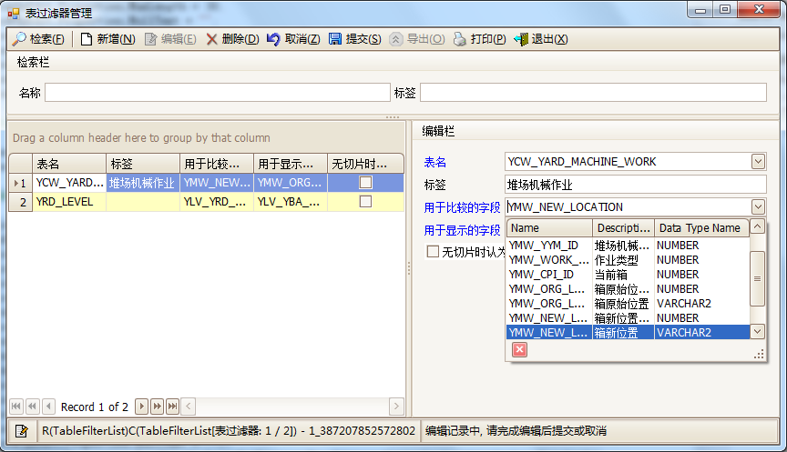

自动为属性赋值
虽然界面上表现的是“当输入新的表名后，标签值会随之更新为该表的Description值”，但我们不应该直接编写界面层、界面控制层代码，因为这是纯粹的业务逻辑，必须编写在业务逻辑层上，也就是实体类TableFilter上：

/// <summary>
/// 表名
/// </summary>
public new string Name
{
get { return base.Name; }
set
{
base.Name = value;
if (Table != null)
Caption = Table.Description;
}
}

实体类TableFilter覆盖重写了其基类TableFilter<T>的Name属性，在新的Name属性的set()语句中，先向其基类的Name属性赋value值，然后找到Table，为Caption属性赋Table.Description值，以达到我们的设计目标。

完整代码

/// <summary>
/// 表过滤器
/// </summary>
[Serializable]
[Phenix.Core.Mapping.ClassDetail("PH_SECTION_TABLEFILTER", "ST_TF_ID", null, CascadingDelete = true, FriendlyName = "切片-表过滤器")]
public class TableFilter : TableFilter<TableFilter>
{
#region 关联表及字段

private Phenix.Core.Data.Schema.Database Database
{
get { return Phenix.Core.Data.Schema.Database.Fetch(null); }
}

/// <summary>
/// 数据库表清单
/// </summary>
public ReadOnlyCollection<Phenix.Core.Data.Schema.Table> DatabaseTables
{
get { return Database.TableList; }
}

/// <summary>
/// 表
/// </summary>
public Phenix.Core.Data.Schema.Table Table
{
get { return !String.IsNullOrEmpty(Name) ? Database.FindTable(Name) : null; }
}

/// <summary>
/// 表字段清单
/// </summary>
public ReadOnlyCollection<Phenix.Core.Data.Schema.Column> TableColumns
{
get { return Table != null ? Table.ColumnList : new ReadOnlyCollection<Phenix.Core.Data.Schema.Column>(new List<Phenix.Core.Data.Schema.Column>()); }
}

#endregion

#region 勾选切片全集

/// <summary>
/// 分配的切片
/// </summary>
public SectionTableFilterList SectionTableFilters
{
get { return GetDetail<SectionTableFilterList, SectionTableFilter>(); }
}

/// <summary>
/// 供勾选的切片全集
/// </summary>
public SectionReadOnlyList SelectableSections
{
get { return SectionTableFilters.CollatingSelectableList<SectionReadOnlyList, SectionReadOnly>(SectionReadOnlyList.Fetch()); }
}

#endregion

#region 覆写属性

/// <summary>
/// 表名
/// </summary>
public new string Name
{
get { return base.Name; }
set
{
base.Name = value;
if (Table != null)
Caption = Table.Description;
}
}

#endregion
}

